Pysanky Design Symbolism

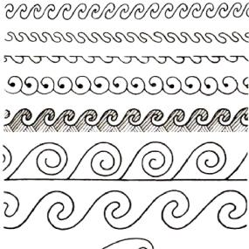 | Eternity Band | Harmony, immortality, infinity, and motion. Evil spirits were said to land on the pysanka and be trapped inside the eternity band.
 | Spiral | Ancient depiction of a snake (Pagan god of earth and water). It is a protection symbol. Evil spirits would get lost and trapped in the spiral.
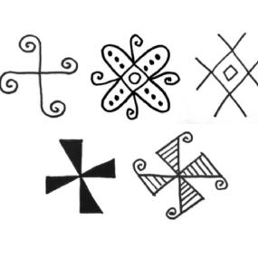 | Windmill/Swastika (Svarha) | Ancient solar symbol. God of the sun, sky, and thunder. Depicts movement of the sun across the sky.
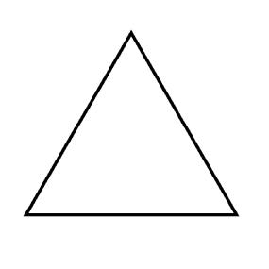 | Triangle | Christian meaning: Holy Trinity, Pagan meaning: mother father and child, earth air and water, or birth life and death.
 | Ladder | Ascension, connection between heaven and earth, perfection
 | Deer, Horse, Ram (or their horns) | Wealth and Prosperity
 | Saw/Wolf’s Teeth | Fire, Life-Giving Heat  Also known as wolf’s teeth, symbolizing loyalty and wisdom
 | Resheto (Netting) | Protection from evil spirits. Usually fills other elements like triangles, circles, squares
 | Wheat | Wishes for a good harvest and good health
 | Dots | Stars
 | Pine Needles | Health, Stamina, Eternal Youth

