Breaking Stalin’s Nose by Eugene Yelchin, A Newbery Honor book
Lesson 3 (covering chapters 3-5): In chapter 3, Sasha’s neighbor gives him a “treat” - a carrot. Food is just one of many necessities that is sacrificed to build a bright Communist future. Sasha explains how his father works for the Soviet secret police. In chapter 4, Sasha’s father comes home from work and Sasha describes how his father catches enemies every day. His father tells him to be aware of suspicious characters on the streets and at school. They visit excitedly about Sasha’s induction into the Young Soviet Pioneers. In chapter 5, Sasha’s world is turned upside down when he witnesses the unjust arrest of his father.
Vocabulary
Secret Police/NKVD – A police organization that arrests enemies to the Communist party.
**The NKVD did not require physical evidence to make arrests, and often used spoken accusations from friends or neighbors to send “enemies” away. It was the organization used to enforce Stalin’s Great Terror.
Discuss and Analyze: Print out the discussion questions on the following page as a handout for students. Analyze the illustration on page 12-13 and tell about communal living, or about the relationship between Sasha and his father.
Possible Research Topics: Was every “enemy of the state” fairly accused? How many were taken away during the “Great Terror” or “Great Purge?” What happened to the children whose parents were taken? How important is it to have a fair legal system, where evidence must be brought forth before an arrest is made?
Additional Videos and Resources:
Learn more about the Secret Police or NKVD: https://kids.kiddle.co/KGB
Learn more about the “Great Purge” or “Great Terror”: https://www.history.com/topics/russia/great-purge
Learn more about Stalinist Russia: https://www.youtube.com/watch?v=cOI8wKFCEIA

Discussion Questions:
Chapter 3 What is the Secret Police/NKVD or the State Security. Why does it exist?
_______________________________________________________________
_______________________________________________________________
Why would Sasha call “craving food” an unimportant matter? Why does Sasha assume children in capitalist countries may have never eaten a carrot?
_______________________________________________________________
_______________________________________________________________
Chapter 4 When Sasha’s father walks into the door, why does everyone look afraid of him?
_______________________________________________________________
_______________________________________________________________
The color of Sasha’s scarf is red to represent the blood spilled for the cause of the Communist party. What are some examples of color being significant to American symbols? What are the differences between the two?
________________________________________________________________________________
________________________________________________________________________________
________________________________________________________________________________
Why would Sasha’s father tell him to go to Aunt Larisa if anything happens to him? What could happen to him? ________________________________________________________________________
________________________________________________________________________________
________________________________________________________________________________
Chapter 5
Why did Stukachov tell the police that Sasha’s father is a criminal? What did he have to gain? Do you think this happened often? __________________________________________________________
_________________________________________________________________________________
_________________________________________________________________________________
Imagine your parent was arrested like this. If you were in Sasha’s shoes, what would you do after the police left? _______________________________________________________________________
_________________________________________________________________________________
_________________________________________________________________________________
_________________________________________________________________________________
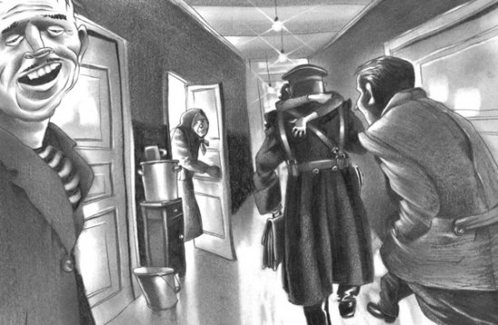
A warm embrace from Sasha for his father, who has just returned home from his work with the Secret Police (NKVD). Illustration found on pgs 12-13. On the right is Stukachov lurking.

Analyze: What does this illustration tell you about communal living? What does it tell you about the relationship between Sasha and his father?
___________________________________________________________________
___________________________________________________________________
___________________________________________________________________

