Breaking Stalin’s Nose by Eugene Yelchin, A Newbery Honor book
Lesson 2: In chapter 1, ten-year old Sasha Zaichik writes a letter to Joseph Stalin, the leader of his country, describing his hopes and dreams to become a Young Soviet Pioneer. He delves into the current political situation and shows the reader hints of Soviet propaganda throughout the chapter with patriotic songs and devotion to the Communist party. In chapter 2, Sasha describes life in a communal apartment during dinnertime, showing through illustrations, the challenges of 48 people sharing a living space.
Vocabulary
Komunalka – A Soviet style of living where people shared apartments with other people and families, sharing living spaces such as the kitchen and bathroom.
Propaganda— Common worldwide and in the Soviet Union, propaganda is biased information spread by a group or person to change or persuade people to believe in a specific ideology.

Possible Research Topics: What role did communal apartments play in Communism? Why was the young generation so patriotic?
Learn more about what was special about the Communal Apartments at Russia Beyond. https://www.rbth.com/society/2015/01/05/in_it_together_how_communal_apartments_shaped_the_outlook_of_generati_41877.html
Learn more about the Young Soviet Pioneers here: https://www.youtube.com/watch?v=8_QRhlq8Hy4
**Here is an example of a Soviet song similar to what Sasha may have sung. https://www.youtube.com/watch?v=3oWqXudgWJc

Chapter 1
- Who does Sasha admire and why?
_____________________________________________________________ _____________________________________________________________ _____________________________________________________________
- Can you see any examples of propaganda in Chapter 1?
_____________________________________________________________
_____________________________________________________________
_____________________________________________________________

- Why do you think Sasha wrote a letter to Stalin? Would you write a letter to your leader?
_____________________________________________________________
_______________________________________________________________________
_______________________________________________________________________
- Can you think of any organizations in your community like the Young Pioneers? If so, compare and contrast.
_____________________________________________________________ _____________________________________________________________ _____________________________________________________________
Chapter 2
- Can you imagine sharing a kitchen and bathroom with 48 people? How does life in communal apartments compare to your life in America?
_____________________________________________________________ _____________________________________________________________ _____________________________________________________________
- How does growing up in communal apartments change how one thinks about community, family, friendship, and government?
_____________________________________________________________ _____________________________________________________________ _____________________________________________________________
- Examine the following photo. What kind of imagery helps us see what life in a communal apartment is like?
_____________________________________________________________
_____________________________________________________________
_____________________________________________________________

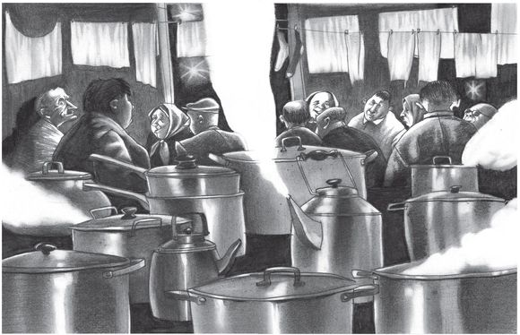

Look at the illustration above. Imagine Sasha’s dinner in a Komunalka and imagine your dinner at home. Fill out the Venn diagram below by listing the similarities and differences between Sasha’s dinner and your dinner.

Sasha’s Your dinner dinner

